MTH2010 Readings and Assignments: Week 6

Week 6 Readings
As early in the week as possible, please read:
- Week 6 online lectures.
- The following sections from the Chapter 9 (Analytical Geometry) of the text Elementary Geometry:
  - Section 9.1 pg. 436-443 (Also read examples 1-6),
  - Section 9.2 pg. 444-452 (Also read examples 1-10), and
  - Section 9.3 pg. 453-461 (Also read examples 1-9).
Week 6 Assignments Overview
Assignment Summary Week 6: | Due Date
Assignment 1: Discussion Questions | Thursday, March 26, 2009
Assignment 2: Group Assignment | Friday, March 27, 2009
Assignment 3: Exam | Friday, March 27, 2009
Assignment 4: Discussion on Exam | Saturday, March 28, 2009
Assignment 5: Team Activity | Saturday, March 28, 2009
Using the navigation on the left, please proceed to the next page.

Week 6

Learning Outcomes:
• Plot points in the rectangular coordinate system.
• Use the distance formula and the midpoint formula.
• Graph linear equations.
• Use the slope formula to find the slope of a linear equation.
• Find equations of lines.

Coordinate Geometry
The focus for this week is on analytic geometry. Analytic geometry is the study of the relationships between number pairs and points. In this type of geometry, you will be able to see how algebra is related to geometry.

The Coordinate Plane
Many of you are probably familiar with the coordinate plane. It is a rectangular grid that can be used for representing points and equations graphically. You can create a coordinate plane by drawing a horizontal number line called the x-axis and a vertical number line called the y-axis. The x-axis and y-axis are your coordinate axes, and their point of intersection is called the origin.
- The location of a point in the coordinate plane is determined by two numbers: the x-coordinate and the y-coordinate of the point.
- The x-coordinate of a point is sometimes called the abscissa, and the y-coordinate is known as the ordinate.
- The coordinates of a point are always written as an ordered pair of numbers having the form (x, y).
- The coordinates of the origin, for example, are (0, 0).
- The sign of the x-coordinate (negative or positive) tells us whether the point is located horizontally to the right of the origin (x > 0), or to the left of the origin (x < 0).
- And similarly, the sign of the y-coordinate (positive or negative) tells us whether the point is located vertically above the origin (y > 0) or below the origin (y < 0). 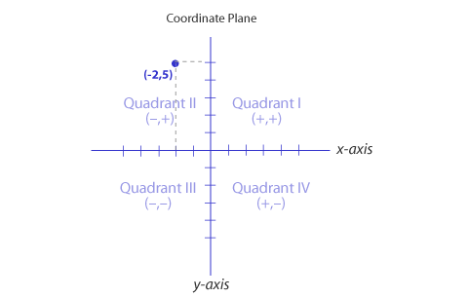

The coordinate axes divide the coordinate plane into four quadrants. The signs of the x- and y- coordinates of a point determine in which quadrant the point is located. Basically, what we have is the following:
Quadrant I | Both x- and y-coordinates positive
Quadrant II | x-coordinate negative, y-coordinate positive
Quadrant III | Both x- and y-coordinates negative
Quadrant IV | x-coordinate positive, y-coordinate negative.

Distance Formula
The distance between two points in a coordinate plane is the length of the segment that joins the two points. If you have a horizontal line or a vertical line, the distance between the two given points can be found by subtracting a single pair of coordinates.
The length of the horizontal line is obtained by calculating the difference between the x-coordinates of the two points. Similarly, the length of a vertical segment is found by subtracting the y-coordinates of the two points.
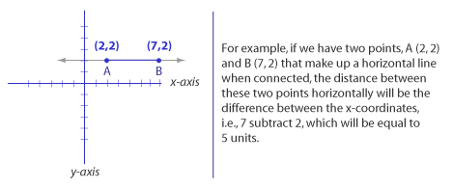

Slanted Lines
Not all lines will be horizontal or vertical. And finding the distance between two points that determine a slanted line is a bit more complicated. It practically involves forming a right triangle, so we have the hypotenuse and the horizontal and verticals segments as the legs of the triangle. If we know the lengths of the legs, we can find the length of the hypotenuse, using a direct application of the Pythagorean theorem, is given by the formula:
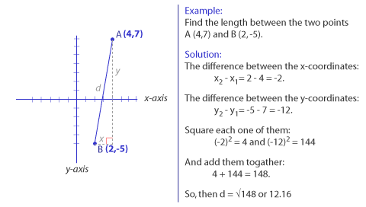
Midpoint Formula
We find the coordinates of the midpoint of a segment joining two points by taking the average of their x-coordinates and then finding the average of their y-coordinates. The midpoint M of the line segment joining A (x1, y1) and B (x2, y2) has coordinates xM and yM, where
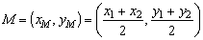
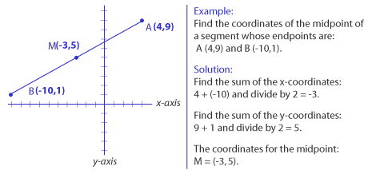

Graphs of Linear Equations
You now know that when we graph an ordered pair it results in a point. An ordered pair can also be a solution to a linear equation in two variables, as you have seen in the previous math course where you learned about functions and so on.
Since there are an infinite number of solutions, there are an infinite number of ordered pairs and an infinite number of points. If we plot these points, we will be graphing the equation. As part of your work this week, you will be graphing linear equations of the form Ax+By = C, where A, B, C are real numbers but A and B cannot both be zero.
How to Graph a Linear Equation
The basic method of graphing a linear equation involves the following steps:
- Look for at least three ordered pairs that are solutions to the equation.
- Plot the points, and
- Draw a line through the points.
Recall that you can also use the intercept method of graphing.
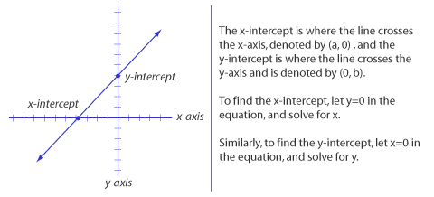
After that you may need one additional ordered pair to have at least three points to graph the equation.
At times, you may have to graph horizontal and vertical lines. Horizontal lines are parallel to the x-axis, while vertical lines are parallel to the y-axis. The equation of a horizontal line will take the form y = b. For a vertical line, the equation will take the form x = a.

Slopes
We usually use the word slope to describe the incline or steepness of a hill. The slope is the change in the vertical distance compared to the change in the horizontal distance as you go from one point to another point along the hill.
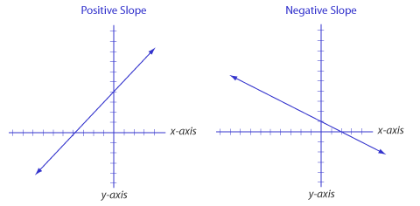
If the change in the vertical distance is greater than the change in the horizontal distance, the slope will be steep. If the change in the horizontal distance is greater than the change in the vertical distance, the slope will be gentle. In a coordinate plane, the slope of a straight line is defined by the change in y divided by the change in x, or simply the ratio of the change in y compared to the change in x.
Stated formally, the slope, m, of a non vertical line that passes through points A (x1, y1) and B (x2, y2) is given by the ratio of the change in the values of their y-coordinates to the change in the value of their x-coordinates:
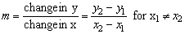
What do you think happens when x1 = x2?

If a line has a positive slope, it climbs up and to the right; if a line has a negative slope, if falls down and to the right. If a line is horizontal, there is no change in y, so m=0. Finally if a line is vertical, there is no change in x. The slope in this case is undefined.
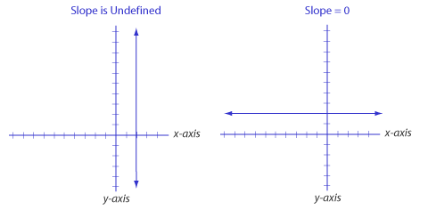
If two non-vertical lines are parallel, then their slopes are equal. If two lines that are neither vertical nor horizontal are perpendicular to one another, then the product of their slope is -1.

Equations of Lines
There are two different methods that we can use to find equations of lines - the Slope-Intercept Form or the Point-Slope Form.

Slope-Intercept Form Method
If we know the slope of the line, m, and the y-intercept b, we can write the equation of the line, using the slope-intercept form: y = mx + b. Look at the following examples:

Example 1:
Write an equation of the line whose y-intercept is -3 and has a slope of 5.

Solution:
Slope m = 5, and b = -3. Therefore, an equation of the line may be written by replacing m and b in y = mx + b with the values given:
y = 5x + (-3) or simply y = 5x - 3.

Example 2:
Line p is parallel to the line y + 4x = 3; line q is perpendicular to the line y + 4x = 3.
- What is the slope of line p?
- What is the slope of the line q?

Solution:
Write the equation of the line given in the form y = mx + b. We have y = -4x + 3. The slope of the line is therefore m = -4.
- Since parallel lines have the same slope, the slope of line p is -4.
- Since perpendicular lines have slopes that are negative reciprocals, the slope of line q is -1/4.

Point-Slope Form Method
If we know the slope m of a line, and the coordinates of a point on the line, or the coordinates of two points on the line, then it is usually easier to write the equation of the line using the point-slope form:
y - y1 = m (x - x1).

Example 3:
Write an equation of a line that is parallel to the line y + 2x = 6 and passes through the point (1,4).

Solution:
Since the lines are parallel, we know that the slope m of the desired line is equal to the slope of the line y+ 2x = 6. We can rewrite y = - 2x + 6, giving us m = -2. Now, using this value of the slope m and the point (x1, y1) = (1,4),

we have:
y - y1 = m (x - x1).
y - 4 = -2 (x - 1)
y - 4 = -2x + 2
y = -2x + 2 + 4
y = -2x + 6

There y = -2x + 6 is the equation of the line that we seek.

Congratulations! This completes the lectures for the course College Math II. You learned about the relationship between lines, line segments, and angles. Then, you looked at various postulates for quadrilaterals and trapezoids. Then, you leaned about polygons, various rules related to triangles, and Pythagoras theorem. The next week focused on circles, arc, tangents, and secants. Next, you looked at area and perimeter of various polygons and solid objects. Finally, you learned about analytical geometry. This includes relating algebra to geometry.

Assignment 1: Discussion Questions
By Thursday, March 26, 2009, choose two of the discussion questions, and post your responses in the Discussion Area. Your response should reflect an understanding of the material covered as it applies to your life, work, and educational experiences. Start reviewing and responding to your classmates as early in the week as possible; post comments on at least two of your classmates' submissions to the Discussion Area. Please refer to the policy for participation found in the Educational Commitment Statement.
Grading Criteria | Maximum Points
Correct explanation of concepts. | 4
Well-formed conclusions. | 4
Participation in discussion with class, feedback, and comments. | 4
Correct spelling and grammar. | 4
Total: | 16
For assistance with any problems you may have when completing this assignment—OR—to offer your assistance to classmates, please use the Problems and Solutions Discussion area located through the left side navigation link.
2 - If lines have the same slope, can you conclude that the lines must be parallel? Why or why not? How else might the lines look when graphed?
3 - Two lines have different slopes but the same y-intercept. What does this tell you about the graphs of the lines and about the solution to the system of the two equations?
5 - Refer to discussion questions from Weeks 1 – 5. Choose one question that you have not answered previously and provide your response.

Assignment 2: Group Assignment
Complete the following group assignment by Friday, March 27, 2009. Your facilitator will assign you to a group for this assignment.
Discuss the use of geometric concepts in real life and give at least four examples. Also, discuss how have you benefited form this course. Post your responses to this Discussion Area. By the end of the week, review and critique the work of other teams, and respond to their comments.
Grading Criteria | Maximum Points
Ability to relate geometric concepts with real-life. | 4
Correct examples given. | 4
Participation. | 4
Total: | 12
For assistance with any problems you may have when completing this assignment—OR—to offer your assistance to classmates, please use the Problems and Solutions Discussion area located through the left side navigation link.

Week 6 exam
1.What are the midpoints of the line segment joining (-3, 5) and (5, -1)?
- What is the y-intercept for the linear equation 3x - 2y = 18?
- As a fraction in lowest terms, find the slope of the line that contains the points (-3, 3) and (5, -1).
- Determine the point of intersection for the lines whose equations are y = x + 3 and y = 3x-1.

